Dater Creator App Description

*Abstract*

The Dater Creator app idea is to give users a way to organize and find date ideas for you and your special someone. You will have the app to specify certain parameters (Amount of money willing to spend, time you have, temperature, level of physical activity) to give the user a realistic date idea.

*Functionality*

**Database** – When the idea was first come up with, the idea was to be able to have an app that allows users to pull date ideas from a bank of ideas on a server and to share ideas with the creators of the app to push out to other devices. However, when the app development first began, we only created a SQL-Lite database to store ideas locally on the device. In the future a database would be desired. The app should come with at least 10 dates hardcoded into the database.

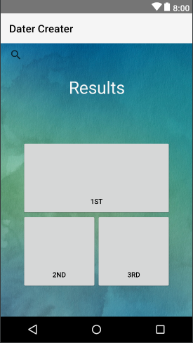 **Random Button** – The random button should pull three random dates from the data base and display them like the displayed picture (Left). The first result will show on top with a brief description. Dates two and three will only show an icon. The idea is that it will give the user a couple of great ideas.

**Magnifying Glass** – The magnifying glass (Picture right) should be on every XML page. The icon, when clicked on, will give the user the ability to search their list of dates anywhere from the app. This should be connected to the database to make a search possible.

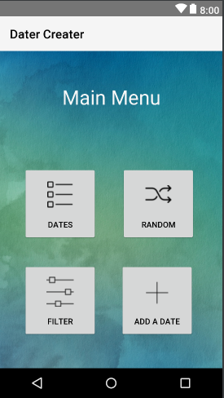**Main Menu** – The main menu is pretty self-explanatory (Pictured Right). Just a central location to get to all the other locations. Create the settings XML to adjust various user settings like font sizes, contrast, etc.

**Filter Button** – The filter button should lead to something similar to what the contacts app looks like on iOS. This should also allow you to filter by cost, inside outside, group size, and temperature. The number of filters allow the user to create custom dates and then filter out all the dates that they have already created. See XML, “custom.xml.”

***//TODO***

* Add more dates to the database
* Make the random button pull dates that would be relevant to previous dates from the user.
* Create separate database for the creators to push out new date ideas.
* Give users the option to push date ideas out to the database for others to use.
* Come up with a mechanism of saying that they have completed the date, and once completed if they liked it or not.
* Link with google maps API for location of date attractions.
* Enable it to use the user’s location.
* A way to keep track of what users like (Which dates they prefer).
* Add a three-dot menu option at the top right corner of the screen. This should include an about page as well as a setting page.